PolSAR Header Tutorial

This tutorial is a walkthrough of how to add header files to PolSAR data (grd files).

1. Open ENVI Classic
2. Go to File->Open Image File
3. Select desired PolSAR file in GRD format
4. 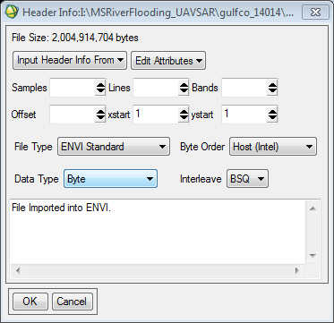Because there is a need to enter header info the following window will appear:
5. Open the ANN file associated with the image in Notepad++
6. Find the samples and lines value for the image
7. Set bands to 1
8. Set Offset to 0
9. Change data type to **floating point**
10. Next click Edit Attributes and go down to map info. The following window will appear:

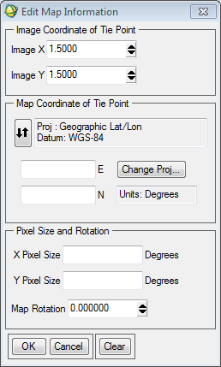

1. Go back to the ANN file that is open in Notepad++
2. Scroll down and find center latitude for upper left pixel (enter this value into Northing)
3. Find the center longitude for the upper left pixel (enter this value into the Easting)
4. Scroll down a little further and find the GRD latitude spacing (enter this value into X pixel size) Note: Although the value in the text file is a negative value, enter a **positive** value. If you do not it will not georeference the image.
5. Find the GRD longitude spacing(enter this value into Y pixel size) and click ok
6. Click ok on the header info window

You have successfully attributed header info to the PolSAR image you are trying to open

1. Now go to your available bands list window and go to the bottom and click display->new display. (A black window for display#1 should pop up.)
2. Double click on the Band 1 of the PolSAR image and it should open in the display window.

Note: If opening in ArcGIS the image may appear black. Don’t sweat, the data is there, the symbology just needs to be changed. Go to the your in the layers window, right click, go to properties and change the symbology so it is not percent clip.